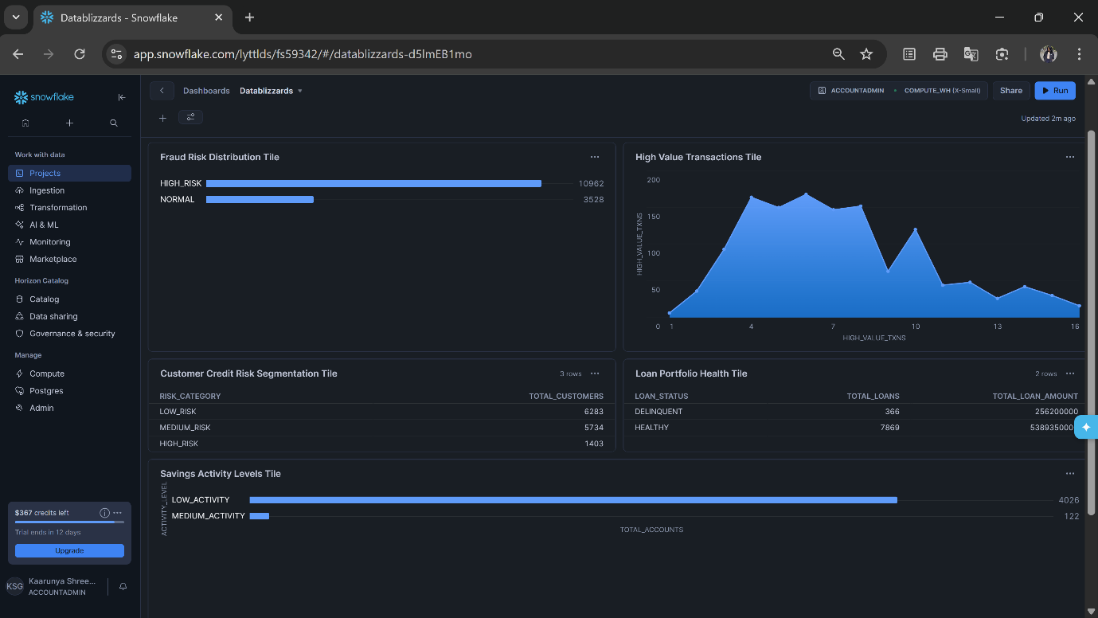

To avoid errors, always set the context first:
USE ROLE ACCOUNTADMIN;
USE DATABASE HACKATHON_DB;
USE SCHEMA SH_GOLD;
All tiles will use:
- Database: HACKATHON_DB
- Schema: SH_GOLD

Fraud Risk Distribution Tile
Shows number of accounts in HIGH_RISK vs NORMAL.
Source
HACKATHON_DB.SH_GOLD.FRAUD_PROBABILITY_SCORE
SELECT
FRAUD_RISK_LEVEL,
COUNT(*) AS TOTAL_ACCOUNTS
FROM HACKATHON_DB.SH_GOLD.FRAUD_PROBABILITY_SCORE
GROUP BY FRAUD_RISK_LEVEL;

High Value Transactions Tile
Shows accounts with transactions > 50,000
Source
HACKATHON_DB.SH_GOLD.FRAUD_PROBABILITY_SCORE
SELECT
ACCOUNT_ID,
HIGH_VALUE_TXNS
FROM HACKATHON_DB.SH_GOLD.FRAUD_PROBABILITY_SCORE
WHERE HIGH_VALUE_TXNS > 0
ORDER BY HIGH_VALUE_TXNS DESC;

Customer Credit Risk Segmentation Tile
Shows how many customers are:
- HIGH_RISK
- MEDIUM_RISK
- LOW_RISK
Source
HACKATHON_DB.SH_GOLD.CUSTOMER_CREDIT_RISK
SELECT
RISK_CATEGORY,
COUNT(*) AS TOTAL_CUSTOMERS
FROM HACKATHON_DB.SH_GOLD.CUSTOMER_CREDIT_RISK
GROUP BY RISK_CATEGORY;

Loan Portfolio Health Tile
Shows Healthy vs Delinquent loans
Source
HACKATHON_DB.SH_GOLD.LOAN_HEALTH_INDEX
SELECT
LOAN_STATUS,
COUNT(*) AS TOTAL_LOANS,
SUM(PRINCIPAL_AMOUNT) AS TOTAL_LOAN_AMOUNT
FROM HACKATHON_DB.SH_GOLD.LOAN_HEALTH_INDEX
GROUP BY LOAN_STATUS;

Savings Activity Levels Tile
Shows account activity levels.
Source
HACKATHON_DB.SH_GOLD.SAVINGS_ACTIVITY_RATIO
SELECT
ACTIVITY_LEVEL,
COUNT(*) AS TOTAL_ACCOUNTS
FROM HACKATHON_DB.SH_GOLD.SAVINGS_ACTIVITY_RATIO
GROUP BY ACTIVITY_LEVEL;

Transaction Channel Analysis Tile
Shows transaction distribution across channels.
Source
HACKATHON_DB.SH_GOLD.CHANNEL_ATV
SELECT
CHANNEL,
TOTAL_TXNS,
AVG_TRANSACTION_VALUE
FROM HACKATHON_DB.SH_GOLD.CHANNEL_ATV
ORDER BY TOTAL_TXNS DESC;

